Lab Environment
In this lab environment, you will be provided with GUI access to a Kali machine. The target machine will be accessible at demo.ine.local.
Objective: Answer the following questions:
- What is the SMTP server name and banner.
- Connect to SMTP service using netcat and retrieve the hostname of the server (domain name).
- Does user “admin” exist on the server machine? Connect to SMTP service using netcat and check manually.
- Does user “commander” exist on the server machine? Connect to SMTP service using netcat and check manually.
- What commands can be used to check the supported commands/capabilities? Connect to SMTP service using telnet and check.
- How many of the common usernames present in the dictionary /usr/share/commix/src/txt/usernames.txt exist on the server. Use smtp-user-enum tool for this task.
- How many common usernames present in the dictionary /usr/share/metasploit-framework/data/wordlists/unix_users.txt exist on the server. Use suitable metasploit module for this task.
- Connect to SMTP service using telnet and send a fake mail to root user.
- Send a fake mail to root user using sendemail command.

Solution:
Step 1: Open the lab link to access the Kali machine.
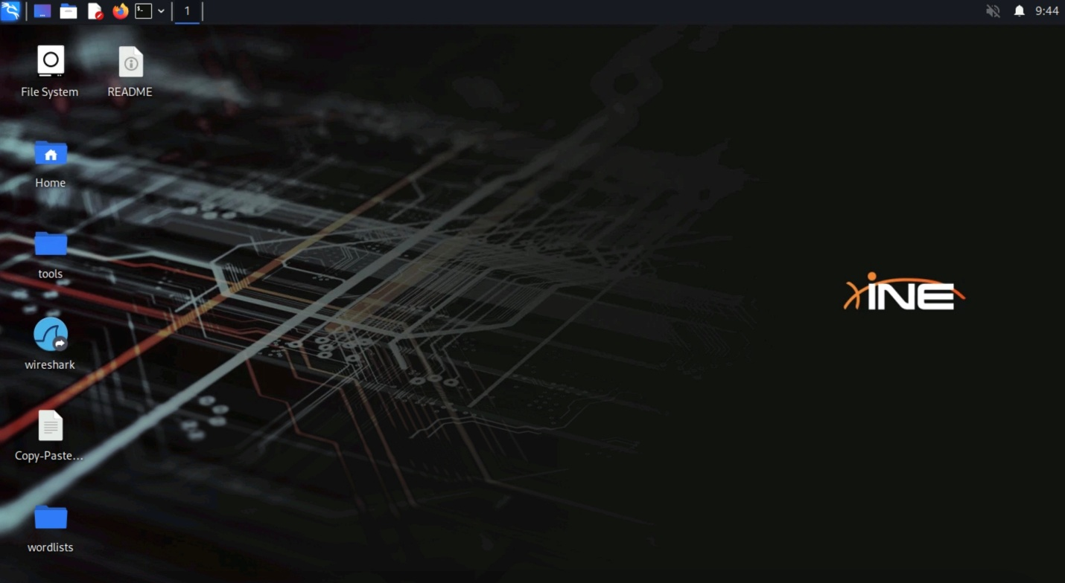
Step 2: What is the SMTP server name and banner.
Answer:
Server: Postfix
Banner: openmailbox.xyz ESMTP Postfix: Welcome to our mail server.
Command:
nmap -sV -script banner demo.ine.local
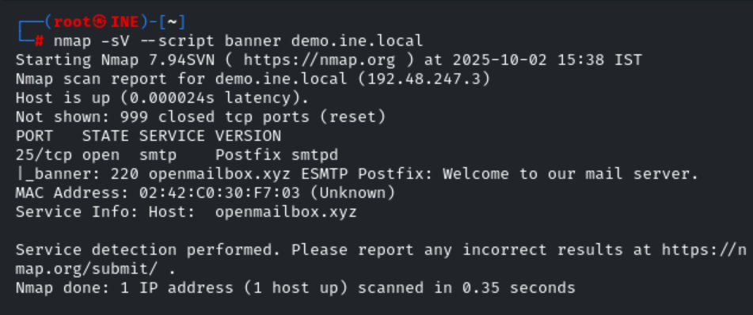
Step 3: Connect to SMTP service using netcat and retrieve the hostname of the server (domain name).
Answer:
openmailbox.xyz
Command:
nc demo.ine.local 25
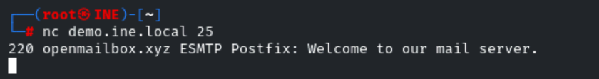
Step 4: Does user "admin" exist on the server machine? Connect to SMTP service using netcat and check manually.
Answer:
Yes
Command:
VRFY admin@openmailbox.xyz
# VRFY = an SMTP command that asks the mail server to “verify” if a given email address exists.
admin@openmailbox.xyz = the address being checked.
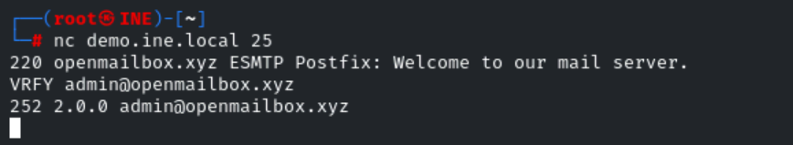
Step 5: Does user "commander" exist on the server machine? Connect to SMTP service using netcat and check manually.
Answer:
No
Command:
VRFY commander@openmailbox.xyz
Step 6: What commands can be used to check the supported commands/capabilities? Connect to SMTP service using telnet and check.
Commands:
telnet demo.ine.local 25
HELO attacker.xyz
EHLO attacker.xyz
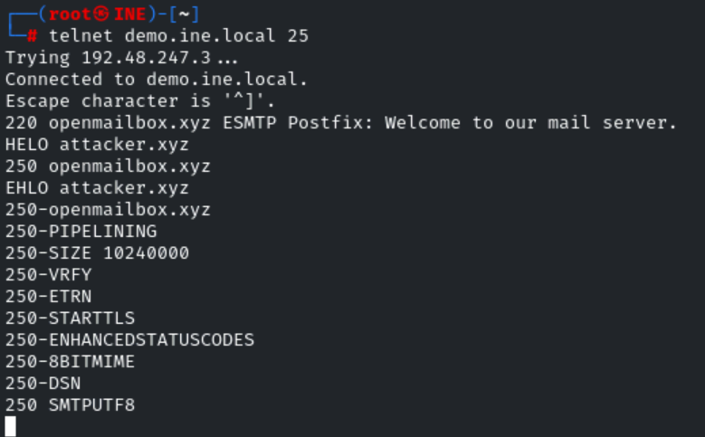

Step 7: How many of the common usernames present in the dictionary /usr/share/commix/src/txt/usernames.txt exist on the server. Use smtp-user-enum tool for this task.
Answer:
8
Command:
smtp-user-enum -U /usr/share/commix/src/txt/usernames.txt -t demo.ine.local
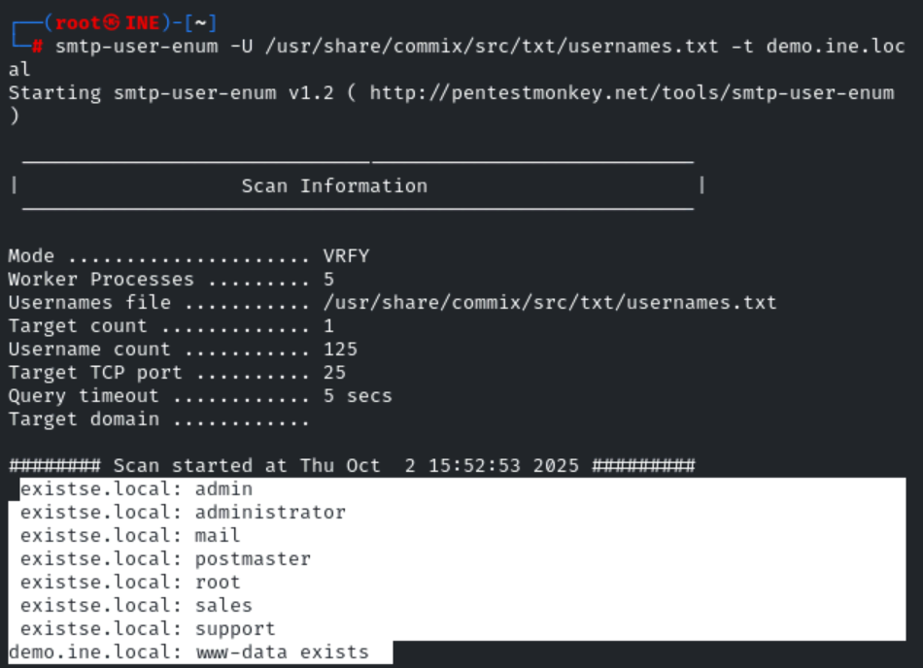
Step 8: How many common usernames present in the dictionary /usr/share/metasploit-framework/data/wordlists/unix_users.txt exist on the server. Use suitable metasploit module for this task.
Answer:
22
Commands:
msfconsole -q
use auxiliary/scanner/smtp/smtp_enum
set RHOSTS demo.ine.local
exploit

Step 9: Connect to SMTP service using telnet and send a fake mail to root user.
Commands:
telnet demo.ine.local 25
HELO attacker.xyz
mail from: admin@attacker.xyz
rcpt to:root@openmailbox.xyz
data
Subject: Hi Root
Hello,
This’s fake
From,
Admin
.
Note: There is a dot(.) in the last line which indicates the termination of data.
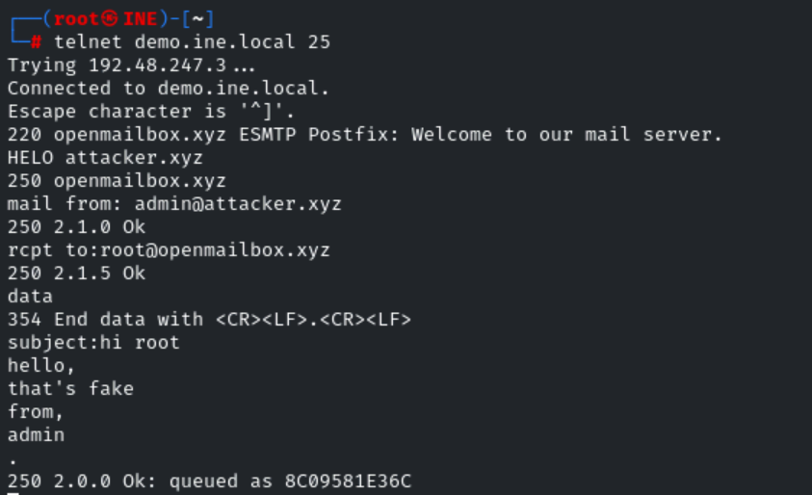
Step 10: Send a fake mail to root user using sendemail command.
Command:
sendemail -f admin@attacker.xyz -t root@openmailbox.xyz -s demo.ine.local -u Fakemail -m "Hi root, a fake from admin" -o tls=no

- -f → From address
- -t → To address
- -u → Subject
- -m → Message body
- -s → SMTP server to connect to (default port 25).
- -o tls=no → do not use TLS

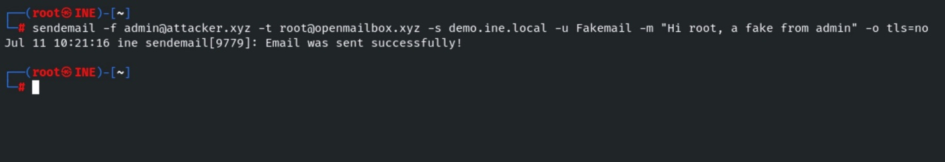

NOTE:
Netcat (nc) is a small program you run in the terminal that lets you send and receive raw data between computers over the network.
👉 It’s called the “Swiss Army knife of networking” because you can use it for many purposes — like:
- Testing if a port is open.
- Making a simple chat between two computers.
- Transferring files.
- Acting as a basic server or client.

telnet demo.ine.local 25
Opens a raw TCP connection to the SMTP service on demo.ine.local (port 25). This gives you a plain text session to speak SMTP.
HELO attacker.xyz
A basic SMTP greeting from the client. It tells the server your hostname (attacker.xyz). The server responds with a 250-code greeting. Use when the client doesn't request SMTP extensions.
EHLO attacker.xyz
An extended SMTP greeting (newer than HELO). It identifies the client and asks the server to list supported SMTP extensions (STARTTLS, AUTH, SIZE, etc.). The server replies with multiple 250- lines—one for the greeting and one for each supported extension.

The smtp-user-enum tool is a command-line utility used in penetration testing to enumerate valid email usernames on an SMTP server.
sendemail is a lightweight command-line tool used to send emails via an SMTP server.

